**Hotel Management Software Development Project**

**[Deliverable 5: Prototype UI & Client Comments]**

**OCTOBER 26th, 2022**

**Client Information :   
Hôtel Manoir Ramezay – Vivian (Proprietor)**   
*492, rue Claude de Ramezay (Route 227),   
Marieville (Québec) J3M 1J6*  
Telephone : (450) 460-3251 | E-mail: [info@manoirramezay.com](mailto:info@manoirramezay.com)



**CERTIFICATIONS**:

I, Red Team LEADER, **Chi-Tao Li # 9730157**, certify that I have contributed to this deliverable.

Signature:  Date: 2022-10-26

I, Red Team MEMBER, **Li Yu # 2295012**, certify that I have contributed to this deliverable.

Date: 2022-10-26

I, Red Team MEMBER, **Patrick Larocque # 0879202**, certify that I have contributed to this deliverable.

Date: 2022-10-26

I, Red Team MEMBER, **Murat Osmonov # 219501**, certify that I have contributed to this deliverable.

Signature: 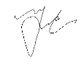Date: 2022-10-26

I, Red Team member, **Gerasimos Vlassopoulos # 2295049**, certify that I have contributed to this deliverable.

Signature: 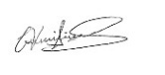 Date: 2022-10-26

|  |  |
| --- | --- |
| Table of Contents |  |
| 1. **Statement of Prior Work ……………………………………………** | **3** |
| 1. **Executive Overview ………………………...……………….……….** | **?** |
| 1. **Summary Description of the Client ……………………...................** | **?** |
| 1. **Description of the Business Problem …………………….………....** | **?** |
| 1. **Revised Narrative Description of the Project ……………………...** | **?** |
| 1. **Usability Guidelines with Explanations ……………………………** | **?** |
| 1. **Copies of Prototype Interface ………………………………………** | **?** |
| 1. **Client Comments …………………………………………………….** | **?** |
| 1. **Description of Prototype Changes ………..………………………...** | **?** |
| 1. **Appendix 1 – Revised User Stories …………………………............** | **?** |
| 1. **Appendix 2 – Revised User Story Tests ………………………….....** | **?** |
| 1. **Appendix 3 – Revised User Story Map …………………………......** | **?** |
| 1. **References/Bibliography …………………………………………….** | **?** |

1. **Statement of Prior Work**

The work herein is possible in part due cumulative learning assignments and projects undertaken in the past, as part of the team’s Software Development curriculum. As such, some of the ideas or technical skills used in this project originate partially from prior work. The table below lists past projects undertaken by members of the Red Team, which may contribute in part to elements found in the scope of this project.

|  |  |  |
| --- | --- | --- |
| Past Projects | Tools Used | Contributor(s) |
| Mock-ups for personal websites, Application Dev 1 | Adobe Photoshop, Cava, Figma | All membres |
| Simulation Program | Java and Java Swing | Chi-Tao Li |
| Car Rental System | MS SQL Server | All members |
| Inventory Management System | Apache Derby Database, Java, and Java Swing | Patrick Larocque |
| Issue Tacker | C#, Google API, .NET, Firebase | Patrick Larocque |
| Added Prior Works  used for this deliverable | Tools Used | Contributor(s) |
| Deliverable 1 Report | MS Word, Instagantt.com (for Gantt Chart) | All members |
| Deliverable 2 Report | MS Word | All members |
| Database course | Draw.io, Lucidchart | All members |
| Deliverable 3 Report | MS Word, Draw.io | All members |
|  |  |  |

1. **Executive Overview**

The following document outlines the red team’s efforts and activities aimed at collecting system requirements for a new information system, designed to solve the business problems that is identified throughout the scope of this project. These requirements were gathered through a series of interviews with Manoir Ramezay. The techniques used to gather system requirements are User Stories. User Stories have the advantage of capturing the client’s perspective as they see themselves working with a system that solves their specific needs. Moreover, many of the tasks, actions and features built into the system will be derived from the User Stories that is gathered over the course of this deliverable.

As with previous reports, the reader will find a summary description of the client, Manior Ramezay, as well as a refined statement of their business problems. Next, the reader will find a narrative description of the proposed new information system, in which its aim is to resolve the problems stated in the prior section. The narrative description of the new information system is informed by the User Stories gathered in the proceeding section. Here, the reader will find a list of User Stories gathered and refined by the red team in collaboration with the staff at Manoir Ramezay. Afterwards, the reader will find a User Story map, which serves to illustrate the actions anticipated by users of the system. The User Story map, shown on Appendix 3, maps out the actions possible by both the receptionist (a generic user within the system) and the manager (having privileged/admin access within the system). Lastly, the reader will find a sort of description of the tools used to complete the User Story map.

1. **Summary Description of the Client**

Manoir Ramezay is a 3-star hotel located in Marieville purchased by its current owners in 2018. The owners are first time hotel operators and are of Chinese ethnicity. They immigrated from China to Canada with their two children. During the four years they have been operating the hotel, their business has been consistently growing. The hotel offers 9 standard rooms, 5 suites, an event space, a restaurant, which currently operates as a rental kitchen, and a spa/hot-tub area, which also operates as a rental service, due to COVID restrictions. The business has a website, which includes features typical for a hotel business, including a landing page which introduces the hotel along with images of its amenities, pages that describe the services offered. Guests can make a reservation through their website, as well as the third-party platforms, namely Expedia, Booking.com, Hotels.com and Priceline.com, along with walk-in reservations or by phone. Their primary method of bookkeeping consists of keeping a record of reservations inside of a physical ledger. This ledger is updated each time a booking is made, through any of the various booking channels. They may also print booking confirmations they receive via email for the purpose of bookkeeping. They have kept most of the legacy systems in place, from when the business was purchased 4 years ago. They have not modified the website, other than for the purposes of COVID updates, and much of the management practices have remained unchanged. Their business has grown since it was acquired, and the staff at Manoir Ramezay has voiced their desire to improve and modernize their management systems to solve the business problems they see themselves facing. Regarding the staff’s computer skills, the owners have working knowledge of Microsoft’s Office suite, along with a basic understanding of navigating the web, and using email services. The accountant uses QuickBooks to manage the finances of the business. The cleaning staff do not use any software tools on a day-to-day basis to complete their duties. Management has expressed a willingness to learn any new software tools, should it help them operate their business and solve their current business problems.

The red team has conducted a series of interviews with Manior Ramezay to best assess the needs and requirements of a potential solution to the business problems at hand. Based on the interviews, several changes were made to the proposed system solution based on the requirements gathered.

1. **Description of the Business Problem**

The hotel doesn’t have an efficient system in place to keep track of room availability across available booking channels. When a room is booked through one of their platforms, the front- desk staff must update a physical ledger or print out a confirmation from their e-mail sent by a third-party platform, to have a unified running tally of past reservations. The front desk staff must then manually change room availabilities across all other platforms to avoid duplicate bookings and to reflect the actual availability. This is a very inefficient process, especially when the hotel is busy, during the summer months. The front-desk staff is often preoccupied with assisting on-site guests and fulfilling requests, so much so that they are unable to keep up with the current methods of data entry. This is a potential risk for double bookings and in overworked front-desk staff. This may lead to poor experience for the guests, leading them to choose another establishment in the future. Moreover, if a repeat guest returns to the hotel to book a room, the front-desk staff must reference the physical ledger or paperwork to find their personal information or preferences (if any were noted). This often leads to the client having to repeat much of the same information that was given during their prior visits.

As it stands, the current business problem has to do with efficient booking management. The current process is inefficient, leading to inaccurate room tallies, overworked front-desk staff, an inability to answer guests’ questions and the potential for poor experience as a result. Writing down all guests’ information on paper is a slow and error prone process and appears to be a pain point with respects to the hotel’s day to day operations. Booking and client information is spread across many tools and platforms, each needing to be cross-referenced every time a booking is made. This creates a bottleneck for the business if it wishes to continue growing.

Front-desk staff needs to be able to quickly verify the guests’ personal information for the check-in and check-out process. This will allow the hotel to stay in control of their bookings and automate repetitive tasks. It is important to the staff to have a real time calendar with up-to-date room availabilities, allowing for quick searching, modifying and deletion of guests’ and reservations. This will improve the experience for repeat guests especially, and if it will allow the staff to work in a more efficient and organized manner. A group booking feature with bulk reservation set-ups may also be a worthwhile addition, given that the hotel often books groups.

Moreover, the proposed information system should integrate with, rather than replace   
existing third-party booking options, as these third-party platforms provide inherent discoverability for the hotel. These platforms are familiar to prospective guests and their functionality is not redundant. Therefore, the proposed application should focus on solving the problem of interconnectivity and intercommunication between booking channels.

1. **Revised Narrative description**

Given that third party booking platforms provide inherent discoverability for the hotel, along with familiar and immediate ways for potential guests to book through the platforms they are familiar with, the proposed information system will only be a business facing tool to be used by hotel staff to retrieve up-to-date room availabilities through an API. The system will also allow hotel staff to complete reservation requests made by guests booking directly through the hotel, by phone, email, walk-in or through the hotel’s website.

The Red Team has identified two primary roles relevant to the system. The first role is the receptionist, who will function as a generic user. The receptionist needs basic authorization, sufficient to create, modify and delete reservations, as well as browse, and update availabilities. The second role is a manger role. The manager will have admin privileges within the system. In addition to being able create, modify, and delete reservations, as well as read and update availabilities, the administrator will be able to create, read, update, and delete users on the system. The administrator will be able to manage user privileges, and the scope of their access to the system.

Both the user and administrator will begin at a login screen, where they will enter their usernames and password. Should they enter valid credentials, they will be logged in, and taken to the home screen with account privileges matching their account credentials. Should they enter invalid credentials, they will be shown an error message. Upon a successful login, the system will initiate API calls to retrieve up-to-date availabilities from third-party booking platforms.

Once at the home screen, the user and the admin both will see some statistics amount the day’s availabilities. The user will have the option to navigate to a reservation’s menu, allowing the user to create a new reservation. Initiating a new reservation will also necessitate payment functionality. They may navigate to a calendar view of the month’s current availabilities. Another view option would be in a form of a list that shows either past, current, or future reservations. From here, the user may be able to search, modify, or delete reservations. There will be a button to refresh availabilities, which will make a series of new API calls to retrieve the most up-to-date booking history. The administrator will have access to the same functionality, however, they will additionally be able to navigate to a user’s tab, where they will be able to create, read, update, or delete users. At any moment, the user and the administrator both should be able to exit the application by clicking a button.

1. **Usability Guidelines with Explanations**

**Guidelines for a Good Website User Experience**

1. A CLEAR WEBSITE PURPOSE

A website must accommodate the needs of the user. The intention and purpose need to be simple and clear on all the pages to help the user interact with what the website has to offer. The intention of the website must be obvious at first glance.   
[(9 Principles of Good Web Design, 2021).](https://www.feelingpeaky.com/9-principles-of-good-web-design/)

1. A CONSISTENT AND SIMPLE COLOR SCHEME MATCHING COMPANY BRAND

Simplicity through a website design can be achieved by the website’s use of color. Color has the power to communicate messages and evoke emotional responses. Sticking to the minimal color scheme that matches with the business’s brand is ideal as to not distract the user. Furthermore, when creating hyperlinks and/or call-to-action links (CTAs), differentiating the colors from the rest of the text enhance the user experience. A call-to-action is content intended to induce a viewer, or reader to perform a specific act, typically taking the form of a directive. [(9 Principles of Good Web Design, 2021).](https://www.feelingpeaky.com/9-principles-of-good-web-design/)

1. USING RELEVANT AND HIGH-QUALITY IMAGES

High-quality and relevant images enhance the user’s experience positively. A poor designed or irrelevant imagery can be harmful to sales, sign-ups, and the overall brand of the company. Now-a-days, displaying low-quality and/or irrelevant images may cause confusion and distract the user. Proper imagery engages the users and it is a tool to clearly communicate the company’s brand message [(Barraclough, 2021).](https://www.expertmarket.co.uk/web-design/web-design-mistakes-to-avoid)

1. PROVIDING A SECURE WEBSITE  
    Users tend to avoid visiting questionable websites because of cyber security risks. A secure website should have an SSL certificate (or a lock icon) on the top left corner of web browser. These certificates encrypt data sent between a site and its user, ensuring that everything stays safe from cyber criminals from stealing user’s personal data [(Barraclough, 2021).](https://www.expertmarket.co.uk/web-design/web-design-mistakes-to-avoid)
2. USING READABLE TYPOGRAPHY  
    Typography should be comfortable to read. Resizing the size of the text to suit the user’s preference is ideal. Screen readers appreciate the comfort that a well-laid out and legible text provides. Reading requires enough cognitive effort, and there is no need to make reading harder. One way to approach a readable typography is to use contrast (for example: dark colored text on white background). Another approach is using an appropriate type-scale on headlines to ensure that the headings have enough visual weight and making the content easy to read. Breakdown of large blocks of text into smaller paragraphs create an easy read as well. Lastly, using fonts with good geometry and balanced letter spacing makes a readable typography for the user. [(Pop, 2022).](https://teleporthq.io/blog/design-tips-for-creating-a-good-user-interface)
3. PROPER USE OF WHITE SPACE  
    White space is the ‘negative’ space between the layout elements, paragraphs, and visual components. Designing with white space in mind will make the content more scannable, digestible, and easier on the eyes. White space is vital for visual separation. It conveys which elements belong together and which are different from one another. White space is a great tool for directing the eye towards essential elements [(Pop, 2022).](https://teleporthq.io/blog/design-tips-for-creating-a-good-user-interface)
4. CONSIDERING SITE SPEED   
    Site speed is an important part of the overall user experience for any website. A user will abandon a website if it loads too slow. The time it takes to load a webpage or a video within the website can frustrate the user. Ultimately, if a website is selling a product, a slow loading time can affect the purchasing decision of the online shopper. Websites with a lot of design features tend to be slower (i.e.: animation, multiple font sizes/type). It is important to consider each element of design, so the website does not slow down unnecessarily [(Nickerson, 2022).](https://tillerdigital.com/blog/12-web-design-best-practices-for-2022/)
5. DESKTOP AND MOBILE-FRIENDLY WEBSITES  
    Now-a-days, many users spend hours on their mobile phones every day for browsing, shopping and other purposes. If the website via mobile is not responsive or difficult to navigate, they may simply abandon the website and opt for their competition’s website [(Dublino, 2022).](https://www.businessnewsdaily.com/9811-effective-business-website-tips.html) A responsive design utilizes one layout and adjusts the content, navigation, and elements of the page to fit the user’s screen. It will reconfigure all design elements whether it’s viewed on a desktop, laptop, tablet, or mobile phone [(Adobe, 2021).](https://xd.adobe.com/ideas/process/ui-design/adaptive-design-vs-responsive-design/)
6. SEGMENT KEY INFORMATION WITH BULLET POINTS  
    Bullet points highlights key points of information that the user seeks in a short amount of time. Bullet points make the proportion of the website content more attractive to the user and will enable them to get all the information they need quicker. Now-a-days, bullet point icons are more than just the standard black dot. The use of various icons as bullet points can be a creative way to attract the user to their website and help represent their point effectively. It forces the reader to isolate the most important points that the website is trying to make without getting caught up in a bombardment of text [(Jiminez, 2022).](https://blog.hubspot.com/marketing/improve-your-websites-user-experience)
7. MINIMIZING POP-UPS AND OVERLAYS

Based on the world leaders in research-based user experience by the Nielsen Norman Group in 2021 (the site formally known as useit.com), Jakob Nielsen condemns the use of pop-ups and overlays as the number one design flaw in recent websites. Pop-ups and/or overlays are additional windows that would display on certain sections of a website page. Examples of pop-ups/overlays include chat rooms, survey forms, a consent banner to use cookies, a window that incentivizes the user to subscribe to their newsletter, to get a promotional code or even just to access their webpage. These pop-ups and overlays obscure or block the user from what they want to access. Though most pop-ups are necessary for privacy security and/or a promotional tool, the user’s experience can be affected negatively. If a user just wants to read the contents of the page, having a bombardment and accumulation of pop-ups/overlays will reduce the user experience when visiting the website [(Top 10 Web-Design Mistakes, 2021).](https://www.nngroup.com/videos/top-10-web-design-mistakes)

1. **Copies of Prototype Interface**

Hand Drawn Prototypes

001

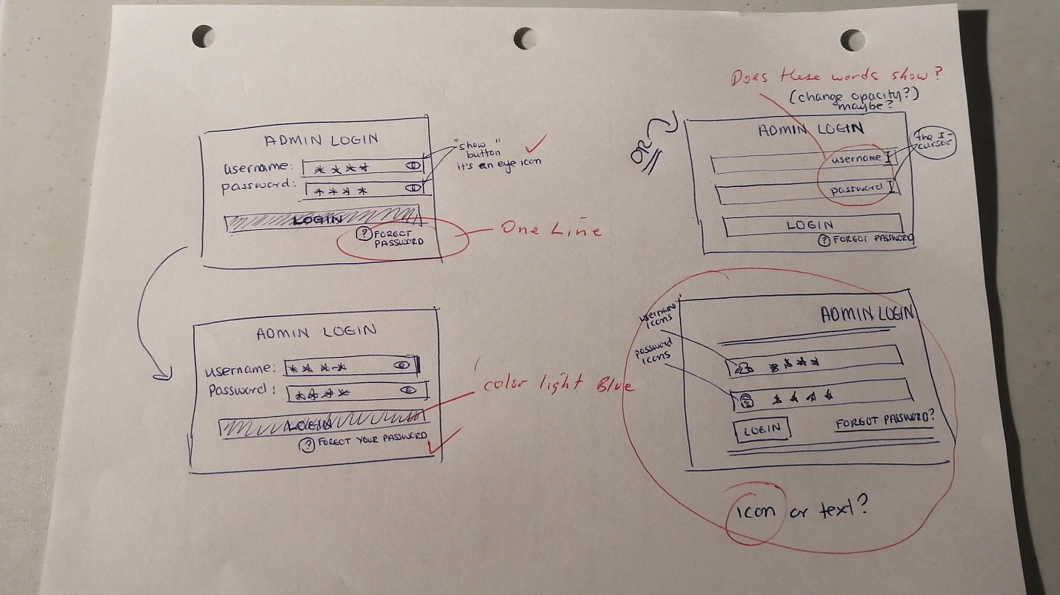

002

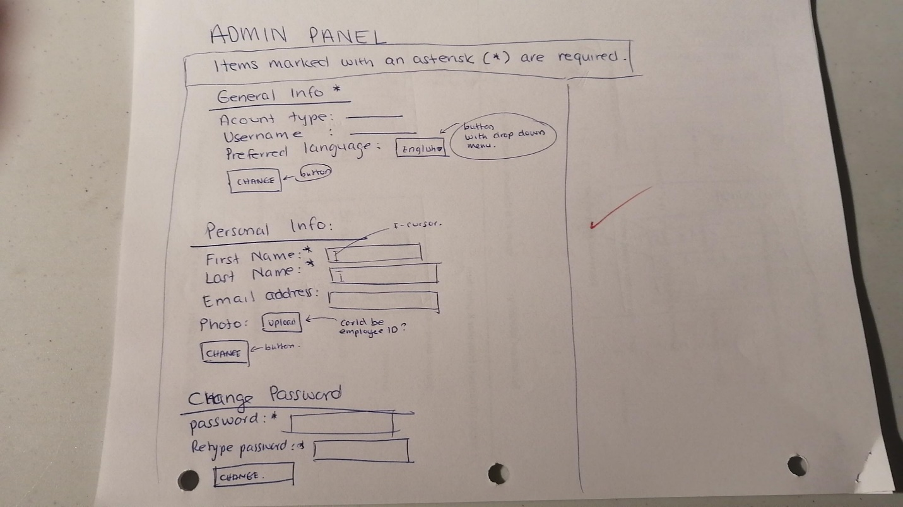

003

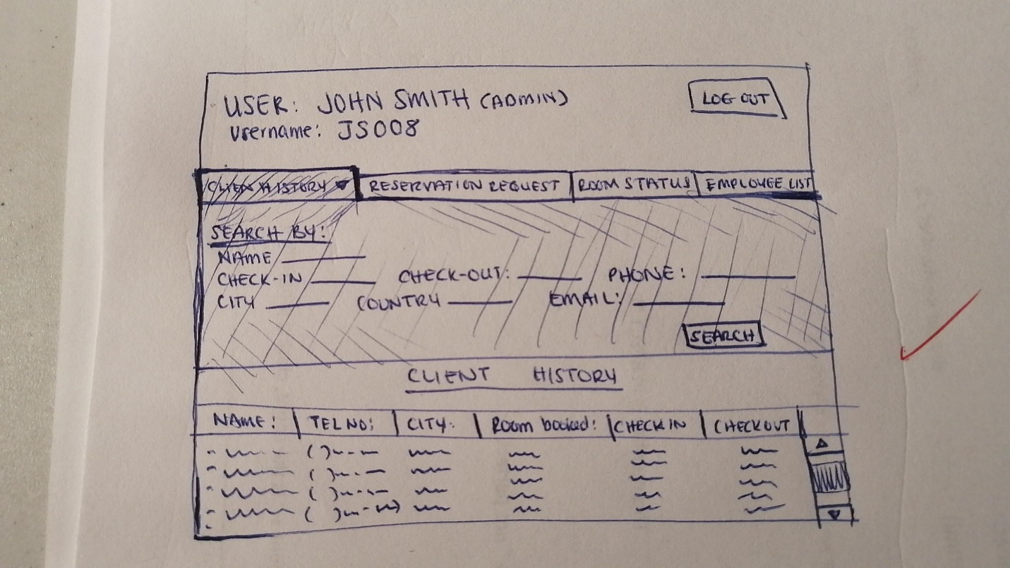

004

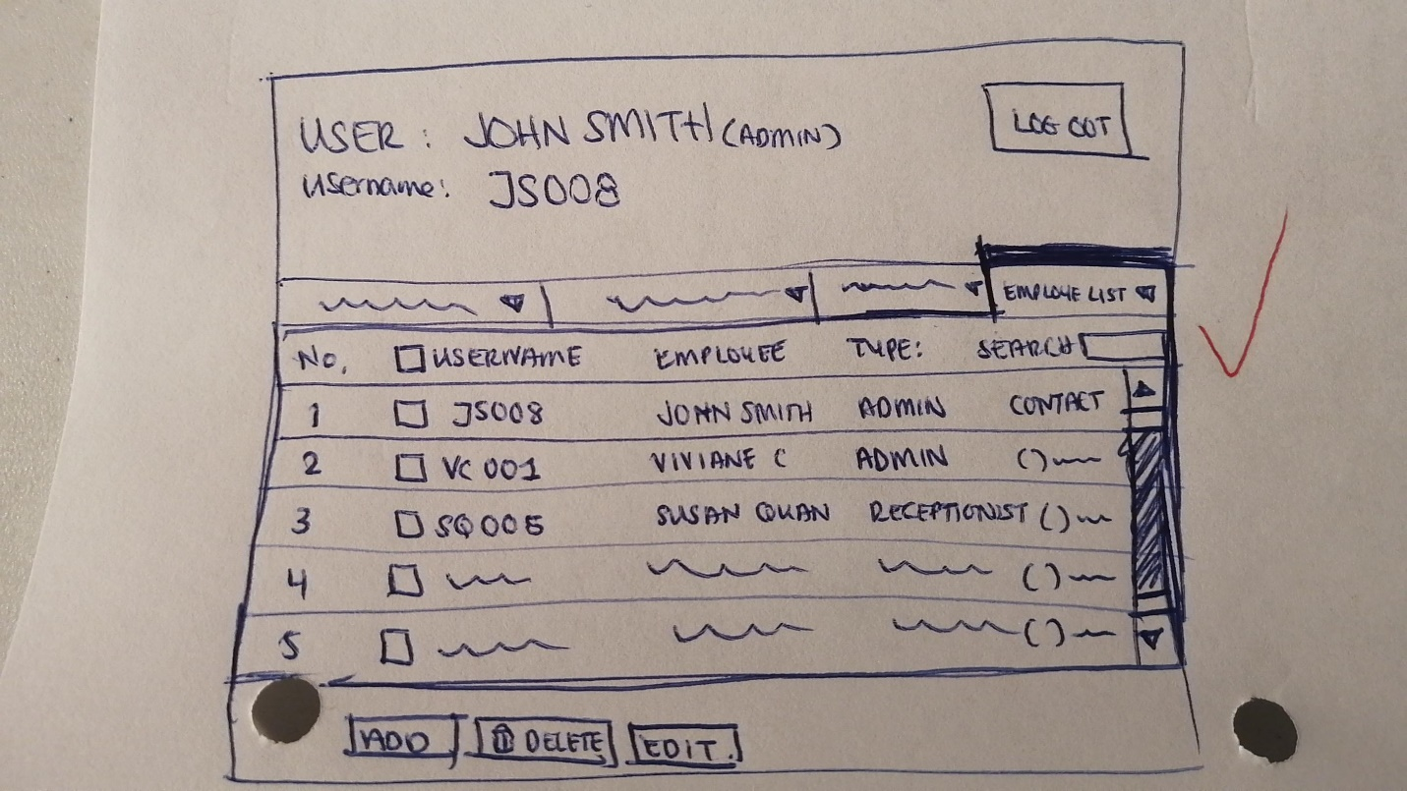

005

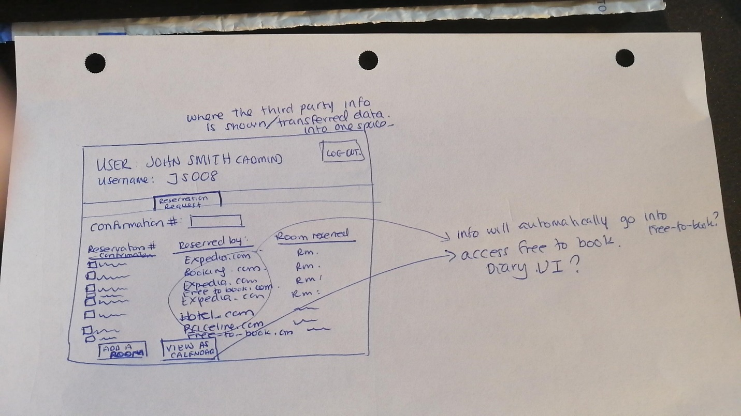

006

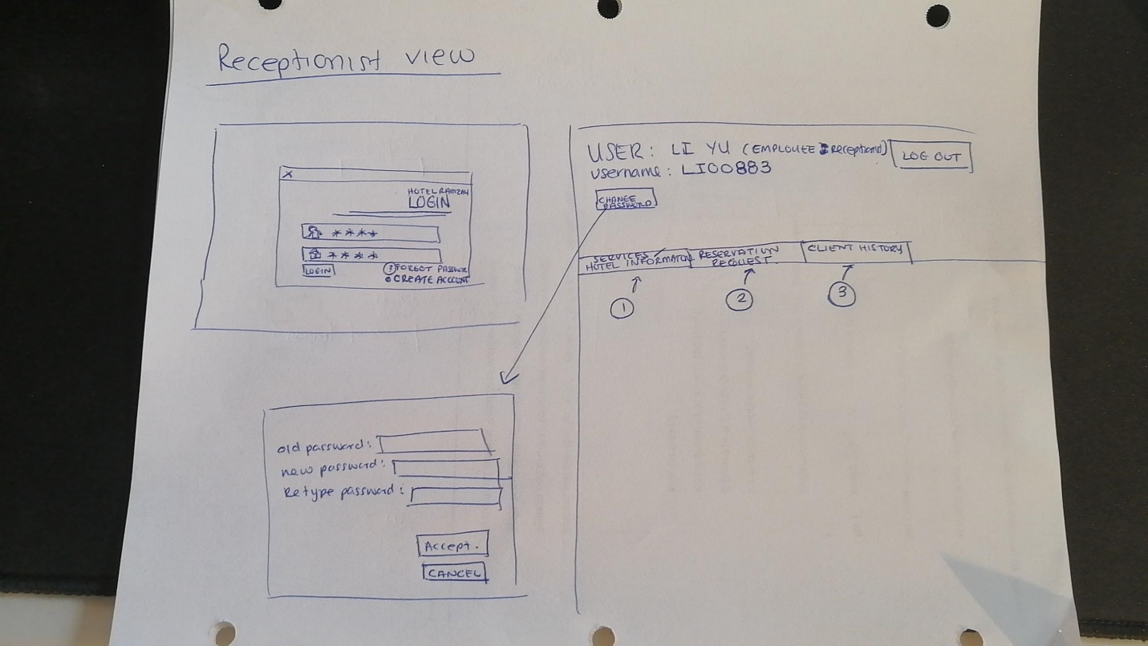

Digital Version of prototypes

1. **Client Comments**

[text here] Describe the process used to interact with client

Client comment on the first prototype (hand-drawn)

1. We would like to be as simple as possible since our staff is not computer saavy.

2. Make the words bigger.

3. Make the button larger.

4. We would like to have the same GUI layout for different screens for ease of use.

5. These drawings look good so far.

6. Good job on prototype (after seen the digital version.)

7. We would like to the submit button to be light blue colour.

8. We prefer icons over text during the log in face.

9. I would like the forgot password option to be on one line.

10. Can my password be saved?

Client comment on the second prototype (computer-drawn)

1. **Description of Prototype Changes**

[text here] Describe the changes from one prototype to the next

1. **Appendix 1 – Revised User Stories**
2. ID: recLogIn

Title: Log In

Story: As a receptionist I would like with a unique identifier

1. ID: recAdd

Title: Add Guests

Story: As a receptionist I would like to add new guest information to the system

1. ID: recModify

Title: Modify Guests

Story: As a receptionist I would like to be able to modify existing guest information.

1. ID: recDelete

Title: Delete Guests

Story: As a receptionist I would like to delete guest records from the unified database

1. ID: recSearchGuest

Title: Search Database for Guest

Story: As a receptionist I would like to obtain guest information.

1. ID: recSearchRes

Title: Search Database for Reservation

Story: As a receptionist I would like to obtain reservation information.

1. ID: recCheckIn

Title: Check In

Story: As a receptionist, I would like to be able to check guests in.

1. ID: recCheckOut

Title: Check Out

Story: As a receptionist I would like to be able to check guests out.

1. ID: recCreateResWalkin

Title: Create a Walk-in Reservation

Story: As a receptionist, I would like to be able to create a reservation when a guest is present.

1. ID: recCreateResPhone

Title: Create a Phone-in Reservation

Story: As a receptionist, I would like to be able to create a reservation when a guest calls in.

1. ID: recModifyRes

Title: Modify Reservation

Story: As a receptionist I would like to modify an existing reservation.

1. ID: recDeleteRes

Title: Delete a Reservation

Story: As a receptionist I would like to delete, cancel, or close a reservation.

1. ID: recRmAvail

Title: Update Room Availability

Story: As a receptionist I would like room availabilities to be automated.

1. ID: recCheckAvail

Title: Check Room Availability

Story: As a receptionist I would like to be able to verify current room availabilities.

1. ID: recCalenderView

Title: View All Bookings

Story: As a receptionist I would like to view a calendar of all scheduled reservations.

1. ID: recGeneInv

Title: Generate Invoice

Story: As a receptionist I would like to generate a booking invoice.

1. ID: recProPay

Title: Process Payment

Story: As a receptionist I would like process a client’s payment.

1. ID: recPhone

Title: Answer the phone

Story: As a receptionist I would like to be able to answer the phone or make a phone call.

1. ID: recGatherInfo

Title: Gather Guest Information

Story: As a receptionist I would like to be able to gather guest’s personal information.

1. ID: recGatherInfo

Title: Gather Guest Information

Story: As a receptionist I would like to be able to gather guest’s payment information.

1. ID: recKeyCard

Title: Room access

Story: As a receptionist I would like to activate a key card.

1. ID: recSendConf

Title: Send Booking Confirmation

Story: As a receptionist I would like to be able to send booking confirmations.

1. ID: recAbort

Title: Exit System

Story: As a receptionist I would like to be able to abort or exit the system.

1. ID: mgrPull

Title: Pull Reports

Story: As a manager I would like to pull occupancy reports from the system.

1. ID: mgrAssign

Title: Assign Tasks

Story: As a manager I would like to assign tasks to my employees.

1. ID: mgrCreateUser

Title: Create Users

Story: As a manager I would like to be able to create new users.

1. ID: mgrModifyUser

Title: Modify Users

Story: As a manager I would like to modify existing users.

1. ID: mgrDelUser

Title: Delete Users

Story: As a manager I would like to delete users.

1. ID: mgrManagePriv

Title: Manage Privileges

Story: As a manager I would like to manage user privileges.

1. ID: mgrSameAsRec

Title: Preform Receptionist Tasks

Story: As a manager I would like to be able to preform the same tasks as the receptionist.

After our client interview, guest user stories were cut, given that the proposed system will not be used by guests, and will instead be an internal tool only.

1. ~~ID: guestRes~~

~~Title: Make a Reservation~~

~~Story: As a guest I would like to be able to make a reservation.~~

1. ~~ID: guestBrowse~~

~~Title: Browse Room~~

~~Story: As a guest I would like to be able to browse room options.~~

1. ~~ID: guestModify~~

~~Title: Modify Reservation~~

~~Story: As a guest I would like to be able to modify my reservation.~~

1. ~~ID: guestCancel~~

~~Title: Cancel a Reservation~~

~~Story: As a guest I would like to be able to cancel my reservation.~~

1. ~~ID: guestInvoice~~

~~Title: Get an Invoice~~

~~Story: As a guest I would like to have an invoice.~~

1. ~~ID: guestPay~~

~~Title: Pay an Invoice~~

~~Story: As a guest I would like to be able to pay my invoice.~~

1. ~~ID: guestInfo~~

~~Title: Provide Personal Information~~

~~Story: As a guest I would like to be able to provide my personal information to the hotel system.~~

1. ~~ID: guestExit~~

~~Title: Exit Booking System~~

~~Story: As a guest I would like to be able to exit the booking system without making a reservation~~.

1. **Appendix 2 – Revised Acceptance Tests**

**User Story 1, Title: Log in**

1a. Given that the user is the receptionist

When valid credentials are input

Then he/she has user level access to the system.

1b. Given that the user is the receptionist

When invalid credentials are input

Then he/she does not have any system access.

**User Story 2, Title: Add Guests**

2a. Given that the user is the receptionist

When Inputting Guest Information into the system

And the guest is not already present within the system

Then the user is successfully added to the database.

2b. Given that the user is the receptionist

When inputting existing guest detail

Then an error message is displayed

And the guest is not re-added to the database

**User Story 3, Title: Modify Guests**

3a Given that the user is the receptionist

When a guest record exists in the database

And personal information is changed

Then the user successfully modifies the guest’s information within the database

3b. Given that the user is the receptionist

When inputting invalid personal information in the input fields

Then an error message is displayed

And the guest’s personal information is not modified

**User Story 4, Title: Delete Guests**

4a Given that the user is the receptionist

When a guest exists within the system

And when searched via their personal information

And when the delete button is selected and confirmed

Then the user successfully is successfully deleted

4b. Given that the user is the receptionist

When the guest does not exist within the database

Then the user cannot delete a non-existent guest for the database

**User Story 5, Title: Search Database for Guest**

5a. Given that the user is a receptionist

When successfully logged in

And when entering valid guest information within a search field

Then he/she can search the database for the corresponding user.

5b. Given that the user is the receptionist

When entering invalid or non-existent guest information into the input field

Then he/she cannot search the database

**User Story 6, Title: Search Database for Reservation**

6a. Given that the user is a receptionist

When successfully logged in

And when entering valid guest reservation info within a search field

Then he/she can search the database for the corresponding reservation

5b. Given that the user is the receptionist

When entering invalid or non-existent reservation information into the search field

Then he/she cannot search the database

**User Story 7, Title: Check In**

7a. Given that the user is the receptionist

When successfully logged in

And when having gathered all required personal and payment information

And when having made a key card for the guest’s room

Then he/she can check in the guest.

7b. Given that the user is the receptionist

When payment information is missing

Then he/she cannot check in the guest.

**User Story 8, Title: Check Out**

8a. Given that the user is the receptionist

When successfully logged in

And when having gathered processed payment of the guest’s invoice

Then he/she can check in the guest.

8b. Given that the user is the receptionist

When having the guest’s invoice has not yet been paid

Then he/she cannot check out the guest.

**User Story 9, Title: Create a Walk-in Reservation**

9a. Given that the user is the receptionist

When successfully logged in

And when having gather the guest’s room and date choices

And when having gathered all required personal and payment information

Then he/she may create a walk-in reservation

9b. Given that the user is the receptionist

When not having gathered all required personal and payment information

Then he/she cannot create a walk-in reservation.

**User Story 10, Title: Create a Phone-In Reservation**

10a. Given that the user is the receptionist

When successfully logged in

And when having gather the guest’s room and date choices

And when having gathered all required personal and payment information

Then he/she may create a phone-in reservation

10b. Given that the user is the receptionist

When not having gathered all required personal and payment information

Then he/she cannot create a phone-in reservation.

**User Story 11, Title: Modify Reservation**

11a. Given that the user is the receptionist

When successfully logged in

And when the reservation in question exists

Then he/she can modify a reservation.

11b. Given that the user is the receptionist

And when the reservation in question does not exist

Then he/she cannot modify a reservation.

**User Story 12, Title: Delete a Reservation**

12a. Given that the user is the receptionist

When successfully logged in

And when the reservation in question exists

Then he/she can delete a reservation.

12b. Given that the user is the receptionist

When the reservation in question does not exist

Then he/she cannot delete a reservation.

**User Story 13, Title: Update Room Availability**

13a. Given that the user is the receptionist

When he/she has successfully logged into the system

And when the systems successfully make API calls to internal booking platforms

Then room availability will be automatically updated

13b. Given that the user is the receptionist

When a system error occurs

Then an exception message will be shown

And the room availability will not be automatically updated

**User Story 14, Title: Check Room Availability**

14a. Given that the user is the receptionist

When he/she has successfully logged into the system

And when having navigated to the corresponding calendar view

Then he/she can view current room availabilities

14b. Given that the user is the receptionist

When failing to navigate to the corresponding calendar view

Then he/she cannot view current room availabilities

**User Story 15, Title: View All Bookings**

15a. Given that the user is the receptionist

When he/she has full access to the system

And when having navigated to the calendar view

Then they may view a calendar of past/present/future bookings

15b. Given that the user is the receptionist

When inputs invalid credentials while logging in

Then he/she may not view a calendar of past/present/future bookings

**User Story 16, Title: Generate Invoice**

16a. Given that the user is the receptionist

When he/she has full access to the system

And when a reservation is confirmed

And when the reservation has beginning and end dates

Then he/she can generate a client invoice.

16b. Given that the user is the receptionist

When a reservation is not confirmed

Then he/she cannot generate a client invoice.

**User Story 17, Title: Process Payment**

17a. Given that the user is the receptionist

When he/she has full access to the system

And when a reservation is confirmed

And when all payment information has been gathered

Then he/she may process a guest’s payment.

17b. Given that the user is the receptionist

When payment information has not yet been gathered

Then he/she may not process a guest’s payment.

**User Story 18, Title: Answer the phone**

18a. Given that the user is the receptionist

When he/she answers a phone call

And the guest wishes to make a reservation

And all personal and payment information has been gathered

Then he/she can add the reservation to the system.

18b. Given that the user is the receptionist

When he/she are occupied with other requests

Then he/she cannot create answer the phone

**User Story 19, Title: Gather Guest Info**

19a. Given that the user is the receptionist

When a client is on the phone or in person

And when the guest wishes to make a reservation

Then he/she can gather guest’s personal information.

19a. Given that the user is not the receptionist

When not in communication with the client

Then he/she cannot gather guest’s personal information.

**User Story 20, Title: Gather Guest Payment Info**

20a. Given that the user is the receptionist

When a client wishes to make a reservation

And when all other personal information has been gathering for that reservation

Then he/she can gather guest’s payment information.

20a. Given that the user is the receptionist

When personal information for a reservation is not yet gathered

Then he/she may not gather guest’s payment information.

**User Story 21, Title: Room access**

21a. Given that the user is the receptionist

When a reservation has been created

And a user checks-in

Then he/she can create the access card to give to the guest

21b. Given that the user is the receptionist

When a guest loses an access card

Then a replacement access card may be granted

And the old access card may be remotely deactivated

**User Story 22, Title: Send Booking Confirmation**

22a. Given that the user is the receptionist

When successfully logged in

And when a reservation has been successfully created

Then he/she can send booking confirmation

22b. Given that the user is the receptionist

When the manager requests all the booking confirmations

Then he/she can send all the confirmations through the system.

**User Story 23, Title: Exit System**

23a. Given that the user is currently using the system

When the user would like to abort or exit the system

And he/she clicks an exit button

Then, they are prompted with a message asking if they are sure they would like to cancel any pending actions

And the system exits.

23b. Given that the user is currently using the system

When the user would like to abort or exit the system

And he/she clicks an exit button

Then, they are prompted with a message asking if they are sure they would like to cancel any pending actions

And if they click no.

Then the system does not exit.

**User Story 24, Title: Pull Reports**

24a. Given that the user is the manager

When he/she has access to the system with manager credentials

And when they access the booking history view

Then he/she may pull an occupancy report

24b. Given that the user is the manager

When logged in without manager credentials

Then he/she cannot pull any reports from the system

**User Story 25, Title: Assign Tasks**

25a. Given that the user is the manager

When he/she has access to the system

Then he/she can assign tasks to the employees

25b. Given that the user is the customer

When he/she does not have access to the system

Then he/she cannot assign tasks to the employees through the system.

**User Story 26, Title: Create Users**

26a. Given that the user is the manager

When he/she has access to the system with manager credentials

And when all new user information fields have been inputted

Then he/she may create a new user

26b. Given that the user is the manager

When he/she has access to the system with manager credentials

And the user already exists

Then an error message will be shown

And the manager will not be able to create the same user

**User Story 27, Title: Modify Users**

27a. Given that the user is logged in with manager credentials.

When there is existing user information.

And when a user information field is changed

Then he/she can modify user information.

27b. Given that the is a manager

When he/she has access to the system without manager credentials

Then he/she cannot modify user information.

27c. Given that the is a manager

When he/she has access to the system with manager credentials

And when the user in question does not yet exist

Then he/she cannot modify user information.

**User Story 28, Title: Delete User**

28a. Given that the user is logged in with manager credentials.

When there is existing user information.

Then he/she can delete a user.

28b. Given that the is a manager

When he/she has access to the system without manager credentials

Then he/she cannot delete user information.

28c. Given that the is a manager

When he/she has access to the system with manager credentials

And when the user in question does not yet exist

Then he/she cannot delete user information.

**User Story 29, Title: Manage privileges.**

29a. Given that the is a manager.

When he/she has access to the system with manager credentials

And when there is existing user information.

Then he/she can manager user privileges.

29b. Given that the user is a manager

When he/she has access to the system without manager credentials

Then he/she cannot manage user privileges.

**User Story 30, Title: Preform Receptionist Tasks**

30a. Given that the user is the manager

When he/she has full access to the system

Then he/she can perform all the same actions as a receptionist.

30b. Given that the user is not the manager.

When he/she try to access the system as the manager

Then he/she cannot access the system at all.

The acceptance tests for guests were also cut, after the decision was made that the application was going to be an internal tool only.

~~17a. Given that the user is the customer~~

~~When he/she has the access to the booking system and looking for the rooms~~

~~Then the customer can make a reservation.~~

~~17b. Given that the user is the customer~~

~~When he/she does not have the access to the booking system~~

~~Then the customer cannot make a reservation.~~

~~18a. Given that the user is the customer~~

~~When he/she has the access to the booking system~~

~~Then the customer can browse the room types.~~

~~18b. Given that the user is the customer~~

~~When he/she does not have the access to the booking system~~

~~Then the customer cannot browse the room types.~~

~~19a. Given that the user is the customer~~

~~When he/she has the existing the reservation~~

~~Then the customer can modify that reservation through the booking system.~~

~~19b. Given that the user is the customer~~

~~When he/she does not have existing the reservation~~

~~Then the customer cannot modify that reservation through the booking system.~~

~~20a. Given that the user is the customer~~

~~When he/she has the existing the reservation~~

~~Then the customer can cancel that reservation through the booking system.~~

~~20b. Given that the user is the customer~~

~~When he/she does not have existing the reservation~~

~~Then the customer cannot cancel that reservation through the booking system~~

~~21a. Given that the user is the customer~~

~~When he/she have a successfully reservation in the system~~

~~Then he/she is able to view the invoice.~~

~~21b. Given that the user is the customer~~

~~When he/she does not have any excising reservation in the system~~

~~Then he/she does not have any access to the invoice.~~

~~22a. Given that the user is the customer~~

~~When he/she have a successfully reservation in the system~~

~~Then he/she is able to pay the bill.~~

~~22b. Given that the user is the customer~~

~~When he/she does not have any excising reservation in the system~~

~~Then he/she does not have any access to the invoice.~~

~~23a. Given that the user is the customer~~

~~When he/she have a successfully reservation in the system~~

~~Then he/she is able to provide personal information.~~

~~23b. Given that the user is the customer~~

~~When he/she does not have any excising reservation in the system~~

~~Then he/she cannot provide personal information.~~

~~24a. Given that the user is the customer~~

~~When he/she is searching for the room availabilities and the hotel is fully booked~~

~~Then he/she can exit the booking system without making a reservation.~~

~~24b. Given that the user is the customer~~

~~When he/she is searching for the room availabilities and is not satisfied with the selection~~

~~Then he/she can exit the booking system without making a reservation.~~

1. **Appendix 3 – Revised User Story Map**

After deliberation, the red team has concluded that the best tool for mapping user stories is Miro. Miro is an online platform that enables whiteboard collaboration, and distributed teams to work together effectively. Miro has great support brainstorming with digital notes to planning and managing agile workflows. User Story Mapping is one of the patterns it supports, and for which templates are available. Miro’s digital sticky notes are easy to work with, as is arranging the digital sticky notes into a User Story map format. Below the reader will find a User Story map for both roles present in the system, the receptionist, and the manager. The red team did not use all the user stories found in appendix 1 within the User Story map, as some of the task details were overly granular and would have necessitated a further break down of what were already fairly simple user stories.

**User Story Map for a receptionist creating a new reservation with a phone-in or walk-in guest.**

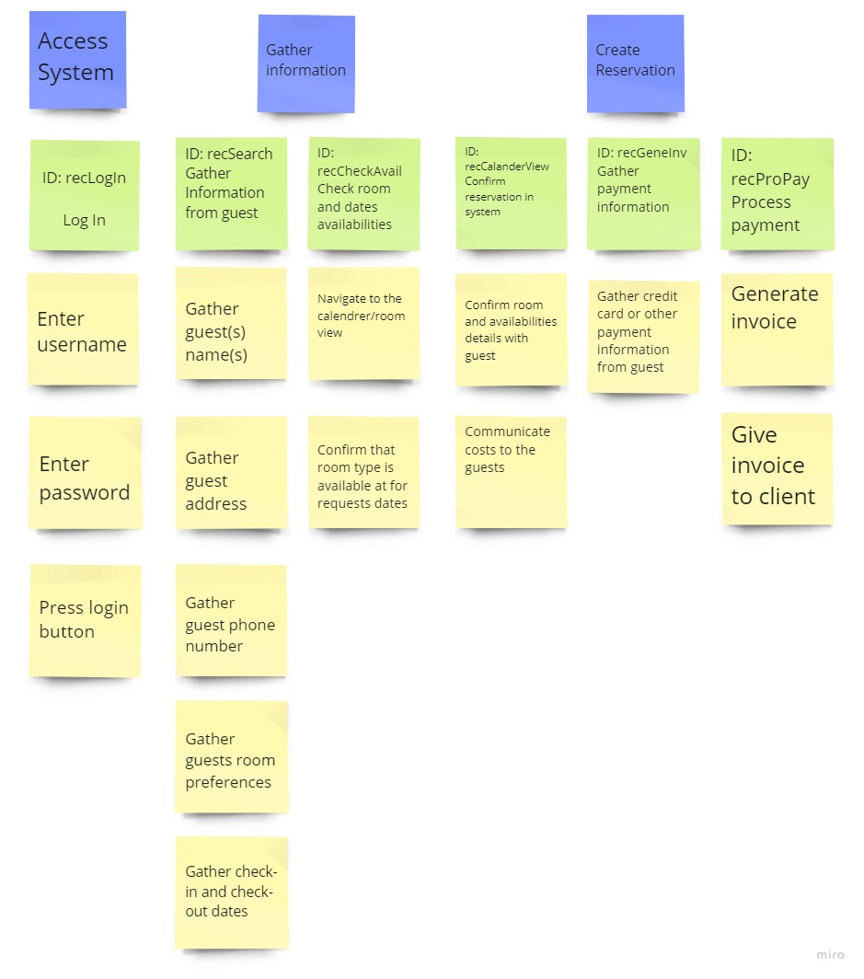

**User story map for a manager.**

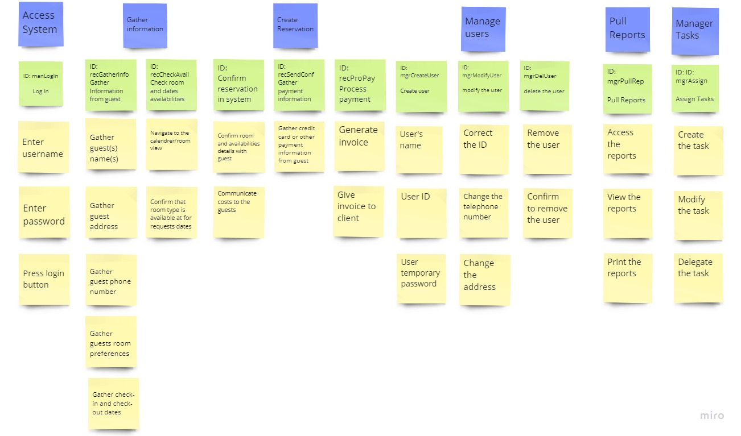

1. **References**

Agile, E. (2021, June 8). Use Cases vs. User Stories: How They Differ and When to Use Them. Easy Agile. Retrieved September 21, 2022, from <https://www.easyagile.com/blog/usecases-vs-user-stories/>

Brandenburg, L. (2018, May 25). 3 Situations that are Absolutely Perfect for Use Cases!Bridging the Gap | We’ll Help You Start Your Business Analyst Career. Retrieved September 27, 2022, from <https://www.bridging-the-gap.com/when-would-you-write-a-use-case/>

Requirements 101: User Stories vs. Use Cases. (2017, October 25). Building Better Software. Retrieved September 21, 2022, from <https://www.stellmangreene.com/2009/05/03/requirements-101-user-stories-vs-use-cases/>

Varga, D. (2020, November 24). User Story vs Use Case: Everything You Need to Know.DigitalNatives. Retrieved September 21, 2022, from <https://www.digitalnatives.hu/blog/user-story-vs-use-case/>

*9 Principles of Good Web Design*. (2021, November 4). Feelingpeaky - Creative Design Agency, London. Retrieved October 8, 2022, from <https://www.feelingpeaky.com/9-principles-of-good-web-design/>

Adobe. (2021, July 10). *Adaptive vs Responsive Design & Key Considerations | Adobe XD*. Ideas. Retrieved October 12, 2022, from <https://xd.adobe.com/ideas/process/ui-design/adaptive-design-vs-responsive-design/>

Barraclough, D. (2021, November 18). *11 Worst Web Design Mistakes to Avoid in 2022*. Expert Market. Retrieved October 8, 2022, from <https://www.expertmarket.co.uk/web-design/web-design-mistakes-to-avoid>

Dublino, J. (2022, September 30). *12 Tips for Building an Effective Business Website*. Business News Daily. Retrieved October 8, 2022, from <https://www.businessnewsdaily.com/9811-effective-business-website-tips.html>

Jiminez, D. (2022, April 1). *10 Tips That Can Drastically Improve Your Website’s User Experience*. Retrieved October 12, 2022, from <https://blog.hubspot.com/marketing/improve-your-websites-user-experience>

Nickerson, B. (2022, April 28). *12 Web Design Best Practices for 2022*. Tiller. Retrieved October 9, 2022, from <https://tillerdigital.com/blog/12-web-design-best-practices-for-2022/>

Pop, S. A. (2022, May 31). *Essential UI Design Tips for Creating a Good User Interface*. TeleportHQ. Retrieved October 9, 2022, from <https://teleporthq.io/blog/design-tips-for-creating-a-good-user-interface>

*Top 10 Web-Design Mistakes*. (2021, October 29). [Video]. Nielsen Norman Group. Retrieved October 12, 2022, from <https://www.nngroup.com/videos/top-10-web-design-mistakes>